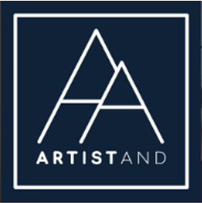
Cancellation Agreement
ArtistAnd
1st – 3rd July 2022
Henley Hall

Host Name: China Jordan
Company: ArtistAnd
Email: china@artistand.co.uk
Address: 3 Edgington Road, London, SW165BS

- General

    - ArtistAnd is committed to providing exceptional services that follow a predetermined plan. You have chosen to participate in the 3 day/ 2 night art & meditation retreat on the 1st-3rd July. The total amount equals £445/575 + £15 Booking Fee.

    - Unfortunately, when a customer cancels without giving enough notice, deposits and reservations made might be lost. For this reason, ArtistAnd has implemented cancellation and refund policies for both parties.

    - ArtistAnd endeavours to make the event

- Payment & Deposits

    - Your registration is complete when we have received your deposit of £150 We do not reserve yours spot without payment which should be completed as soon as possible.

    - A confirmation of your payment and booking will be sent to you via email.

    - Your remaining balance of £295 if sharing/£425 for single occupancy, will be due up to 4 weeks prior to the event (3/06/2022)

- Cancellation Request

    - Cancellation requests may be submitted via an email to china@artistand.co.uk. Please see Section V for more information.

- Refund Policy

- If the client would like to cancel, they will be entitled to a full refund, minus £50 administration fee if the room can be filled.
- In the event that the room cannot be filled, the refund will be no refundable.
- ArtistAnd will endeavour to try to ensure all rooms are filled.
- In the event of cancellation by the host, the client will be entitled to a full refund.
- In the event of cancellation by the retreat venue, the client will be entitled to a full refund.
- Any persons that are absent to the event will not be refunded.

- Covid policy

- In the event of government guidelines restricting the country and requiring the event to be cancelled or postponed, the client shall receive a full refund or the option to transfer their place to another date.

- In the event of the client contracting the virus prior to the workshops and written proof, the client will be entitled to a refund, minus the deposit. Please see II.iii for amounts.

- If the client has taken sick for any other illness, the client will not be entitled to a refund of any kind unless at the discretion of the host.

We thank you in advance for your compliance.

China
ArtistAnd

